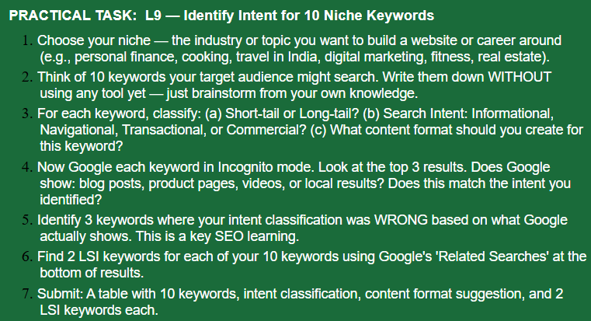

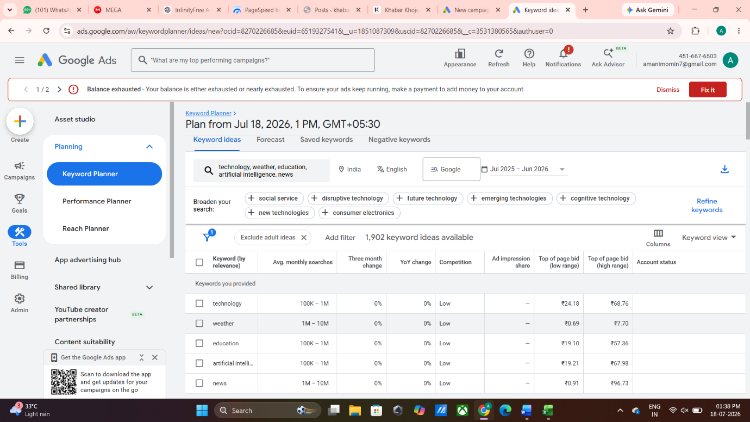

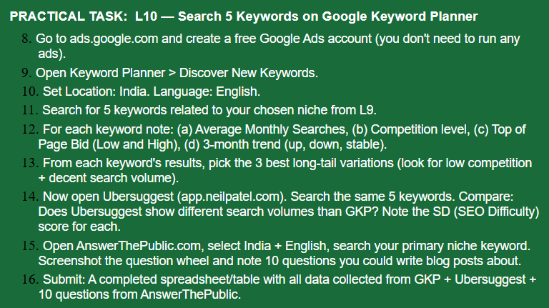

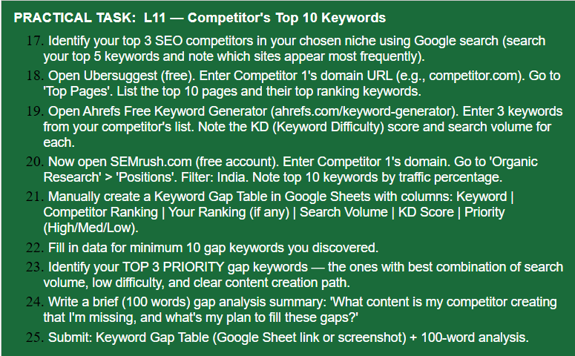
Top 3 SEO Competitors
Based on Google searches for news-related keywords, I identified the following top SEO competitors for KhabarKhojo:
- The Indian Express — indianexpress.com
- Times of India — timesofindia.indiatimes.com
- Hindustan Times — hindustantimes.com

Competitor Keyword Research
For competitor research, I used the first competitor, The Indian Express, and reviewed its top-performing pages and keyword opportunities using Ubersuggest, Ahrefs Keyword Generator and SEMrush Organic Research.

Keyword Gap Table
Keyword | Competitor Ranking | Search Volume | KD Score | Priority
Ahmedabad News | Top 10 | High | Medium | High
Ahmedabad News Today | Top 10 | High | Medium | High
Gujarat News | Top 10 | High | High | Medium
Gujarat News Today | Top 10 | High | Medium | High
Ahmedabad Weather | Top 10 | High | Medium | High
Ahmedabad Crime News | Top 10 | Medium | Low | High
Gujarat Politics News | Top 10 | Medium | Medium | High
Ahmedabad Breaking News | Top 10 | Medium | Medium | High
Gujarat Latest News | Top 10 | High | Medium | Medium
Ahmedabad News Live | Top 10 | Medium | Medium | Medium

Competitor Gap Analysis:
My competitors are regularly creating content around Ahmedabad news, Gujarat news, crime, weather, politics and breaking local updates. Their websites publish fresh and location-focused articles that target users searching for current information. KhabarKhojo already covers similar news categories, but there is an opportunity to create more focused content around specific local keywords. My plan is to target keywords such as “Ahmedabad Crime News,” “Ahmedabad Weather,” and “Gujarat News Today” through regular, original and timely articles. I will optimize the title, URL, headings, meta description, images, alt text and internal links for these keywords. This can help KhabarKhojo improve its visibility and attract more relevant local search traffic

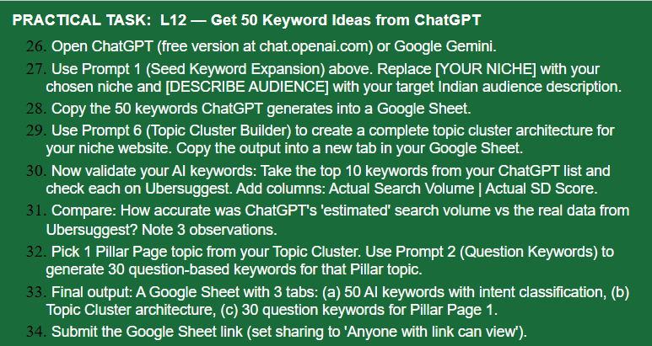Google sheet link ,
https://docs.google.com/spreadsheets/d/1YaaaysPRUaYX6L4EW89VH8qAp0TbOaPEUAyFr8_g1dY/edit?usp=sharing
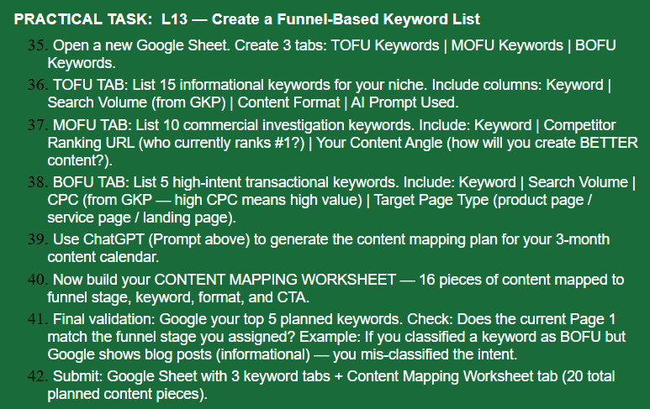
https://docs.google.com/spreadsheets/d/1msfo-GhdK7nFeLDLTCi8WdWjIKdp7IgWWD6CWN-VF1A/edit?usp=sharing

